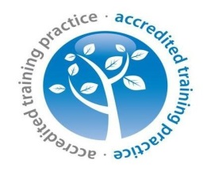
  - WELLINGTON
  - Medical Practice

Measles Outbreak
We have been notified by Public Health that there has been an outbreak of Measles nationally but there have been increased cases reported across the West Midlands.
Please make sure all children receive the MMR vaccine.
Any patient who has a rash preceded by a fever, should telephone the practice – once you arrive in the practice you will be appropriately isolated to minimise the risk of transmission to others.

